DANGOTE CEMENT PLC
Digital KPI Automation & Data Quality System
Technical Appendix
────────────────────────────────────────────────────────────
Challenge 4 — Dangote Industries Innovation Challenge
July 2026

Table of Contents
1. System Architecture Overview
2. Full KPI Taxonomy
3. Complete Data Model
4. Entity Relationship Diagram
5. SharePoint List Structure
6. Power Automate Flow Diagram
7. Validation Rule Library
8. Power BI Role-Level Security Design
9. Implementation Prerequisites & Assumptions
10. Statement of Data Limitations
11. Business Case — Digital KPI Automation
12. Implementation Roadmap
13. Risk & Safety Assessment

1. System Architecture Overview

1.1 Problem Context
Dangote Cement Plc (DCP) operates four cement plants across Nigeria: Obajana (16.25 Mta, 5 kiln lines), Ibese (12 Mta, 4 lines), Gboko (4 Mta), and Okpella (3 Mta). Plant-performance reporting has depended on manual daily, monthly, and year-to-date KPI data compiled in local Excel files and emailed to management. This process creates six systemic pain points: delays (management decisions on stale data), inconsistent templates across plants, missing KPI records with no enforcement, weak traceability of submissions, no visibility into exceptions until month-end, and manual errors entering reports uncorrected.

1.2 Solution Architecture
The proposed solution is a full Microsoft Power Platform stack: Power Apps (Canvas) for data entry, SharePoint Lists for entry-tier storage, Power Automate for validation/approval/escalation workflow, Dataverse for validated storage, and Power BI with Row-Level Security for role-based reporting. The architecture follows a two-tier storage pattern to minimise licensing cost while maintaining data integrity.

1.3 Data Flow
The data flow is linear: Plant operators submit raw readings via a standardised Power Apps form backed by SharePoint Lists. Power Automate triggers on new submissions, runs completeness and range validation, and routes clean submissions to the Plant Manager for approval. Approved data is promoted to Dataverse. Power BI reads exclusively from Dataverse, with RLS filtering by the logged-in Microsoft 365 user's role
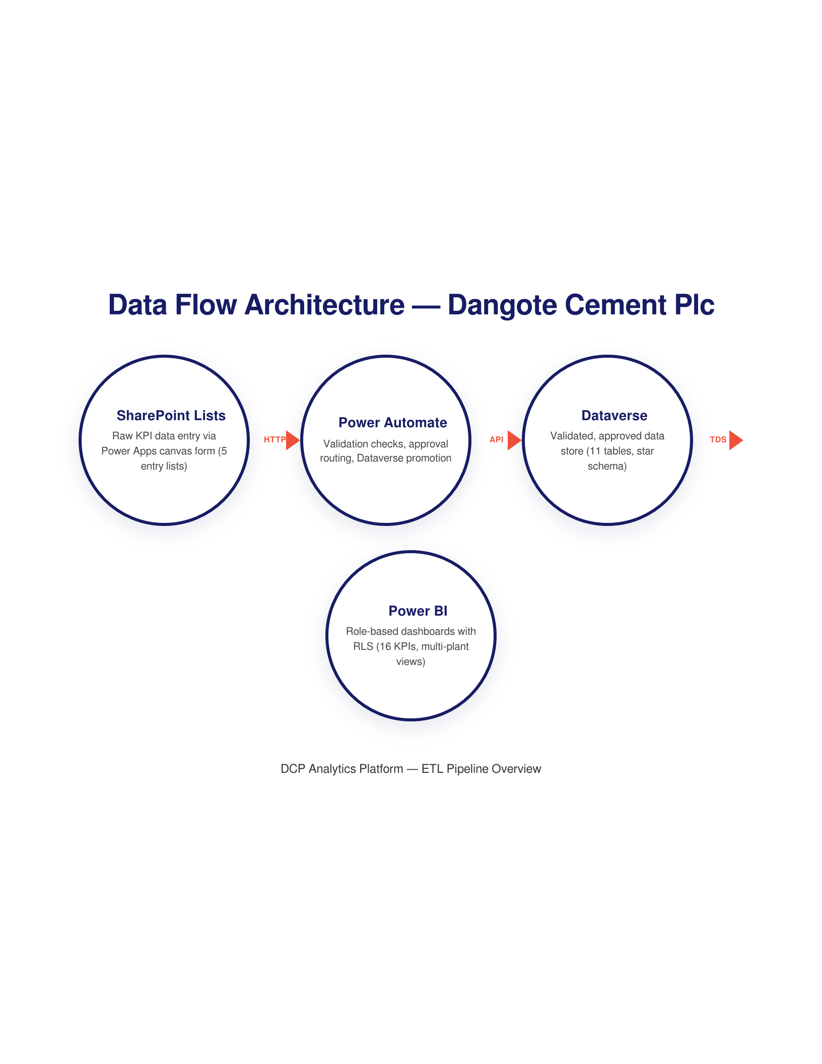

1.4 Technology Stack
Layer | Tool | Purpose
Data Entry & Forms | Power Apps (Canvas App) | Standardised KPI input interface for plant operators
Workflow & Validation | Power Automate | Automated validation, sign-off routing, escalation
Entry-Tier Storage | SharePoint Lists | Low-cost raw data capture (standard M365 license)
Validated Storage | Microsoft Dataverse | Clean, relational store with enforced integrity & RLS
Reporting & Dashboards | Power BI | Role-based dashboards with RLS filtering
Identity & Access | Microsoft 365 + Power BI RLS | Authentication via M365; authorisation via data model

1.5 Two-Tier Storage Rationale
Dataverse alone would be the textbook answer but requires Power Apps Premium licensing for every user — expensive across 4 plants with dozens of operators. SharePoint alone is cheap but has no enforced relationships, 5,000-item view limits, and weak integrity. The two-tier design lets operators work in the cheap tier (SharePoint via standard M365 licenses) and only promotes validated, approved data to the expensive, secure tier (Dataverse). Power BI reads only from Dataverse, so what reaches the dashboard is clean by construction.

2. Full KPI Taxonomy

2.1 Core KPIs — Daily (15)
These 15 KPIs are operationalised in the live system. Reported daily, tracked in the Power Apps form, validated by Power Automate, and visible in Power BI.
# | KPI Name | Category | Unit | Target / Benchmark
1 | Clinker Production Volume | Production | Tonnes/day | Per plant capacity
2 | Cement Production Volume | Production | Tonnes/day | Per plant capacity
3 | Kiln Utilization Rate | Production | % | ≥ 85%
4 | Overall Equipment Effectiveness (OEE) | Production | % | ≥ 85%
5 | Clinker Factor | Production | Ratio | ≤ 0.78
6 | Specific Heat Consumption | Energy | kcal/kg clinker | ≤ 750 kcal/kg
7 | Specific Power Consumption | Energy | kWh/tonne | Per subsystem benchmark
8 | Thermal Substitution Rate (TSR) | Energy | % | ≥ 10%
9 | Free Lime Content | Quality | % | ≤ 1.5%
10 | Blaine Fineness | Quality | cm²/g | Per grade specification
11 | Off-spec Batch Rate | Quality | % | ≤ 2%
12 | PM Compliance Rate | Maintenance | % | ≥ 90%
13 | Mean Time Between Failures (MTBF) | Maintenance | Hours | Trending upward
14 | Maintenance Cost per Tonne | Maintenance | ₦/tonne | Per budget
15 | Submission Timeliness | Governance | Status | 100% on-time
Note: KPIs are not entered directly by operators. Operators enter raw input values (meter readings, fuel quantities, downtime hours, lab results). The system calculates KPI values from those inputs. Validation rules apply at both raw input and calculated KPI levels.

2.2 Supporting KPIs — Appendix Layer (~10)
These KPIs are reported weekly or monthly and documented here as part of the full taxonomy but are not operationalised in the daily submission form.

KPI | Category | Frequency
Lime Saturation Factor (LSF) | Quality | Daily (lab)
Silica Modulus (SM) | Quality | Daily (lab)
Alumina Modulus (AM) | Quality | Daily (lab)
28-day Compressive Strength | Quality | Weekly
Mean Time to Repair (MTTR) | Maintenance | Monthly
Reactive vs. Planned Maintenance Ratio | Maintenance | Monthly
Fuel Cost per Tonne of Clinker | Energy/Finance | Monthly
TSR Detail by Fuel Type | Energy | Monthly
Packing & Dispatch Volume | Production | Daily
Kiln Feed Rate | Production | Daily (SCADA)
Plant Capacity Utilization Rate | Production | Daily (calculated)
Manufacturing Cost per Tonne | Finance | Monthly

3. Data Model Summary
The system uses a star schema of 11 tables — 4 dimension tables holding reference masters and 7 fact tables holding operational data. All relationships are Many-to-One; there are no Many-to-Many relationships. Full column definitions, data types, and relationships are shown in the Entity Relationship Diagram in Section 4.
Table | What It Stores | Storage Tier
DIM_Plant | One record per plant — capacity, location, line count | Dataverse
DIM_KilnLine | One record per kiln line — design capacity, rated throughput | Dataverse
DIM_User | One record per system user — role, plant, M365 email (RLS key) | Dataverse
DIM_Role | Five system roles and their approval/escalation permissions | Dataverse
FACT_DailySubmission | Master record per plant per day — tracks submission lifecycle | SharePoint → Dataverse
FACT_ProductionInput | Raw inputs for KPIs 1–6 (clinker, cement, OEE, utilization) | SharePoint → Dataverse
FACT_EnergyInput | Fuel consumption and power readings for KPIs 7–9 | SharePoint → Dataverse
FACT_QualityInput | Lab test results and batch QC data for KPIs 10–12 | SharePoint → Dataverse
FACT_MaintenanceInput | Equipment maintenance data for KPIs 13–15 | SharePoint → Dataverse
FACT_ValidationLog | System-generated exception and audit trail — never user-written | Dataverse only
FACT_SubmissionTimeliness | Auto-generated KPI 16 record per plant per day | Dataverse only
See the Entity Relationship Diagram in Section 4 for the full column-level definition, data types, primary and foreign keys, and inter-table relationships.

4. Entity Relationship Diagram
The Entity Relationship Diagram below shows all 11 tables, their columns, primary and foreign keys, and the relationships between them.
click here for clearer image
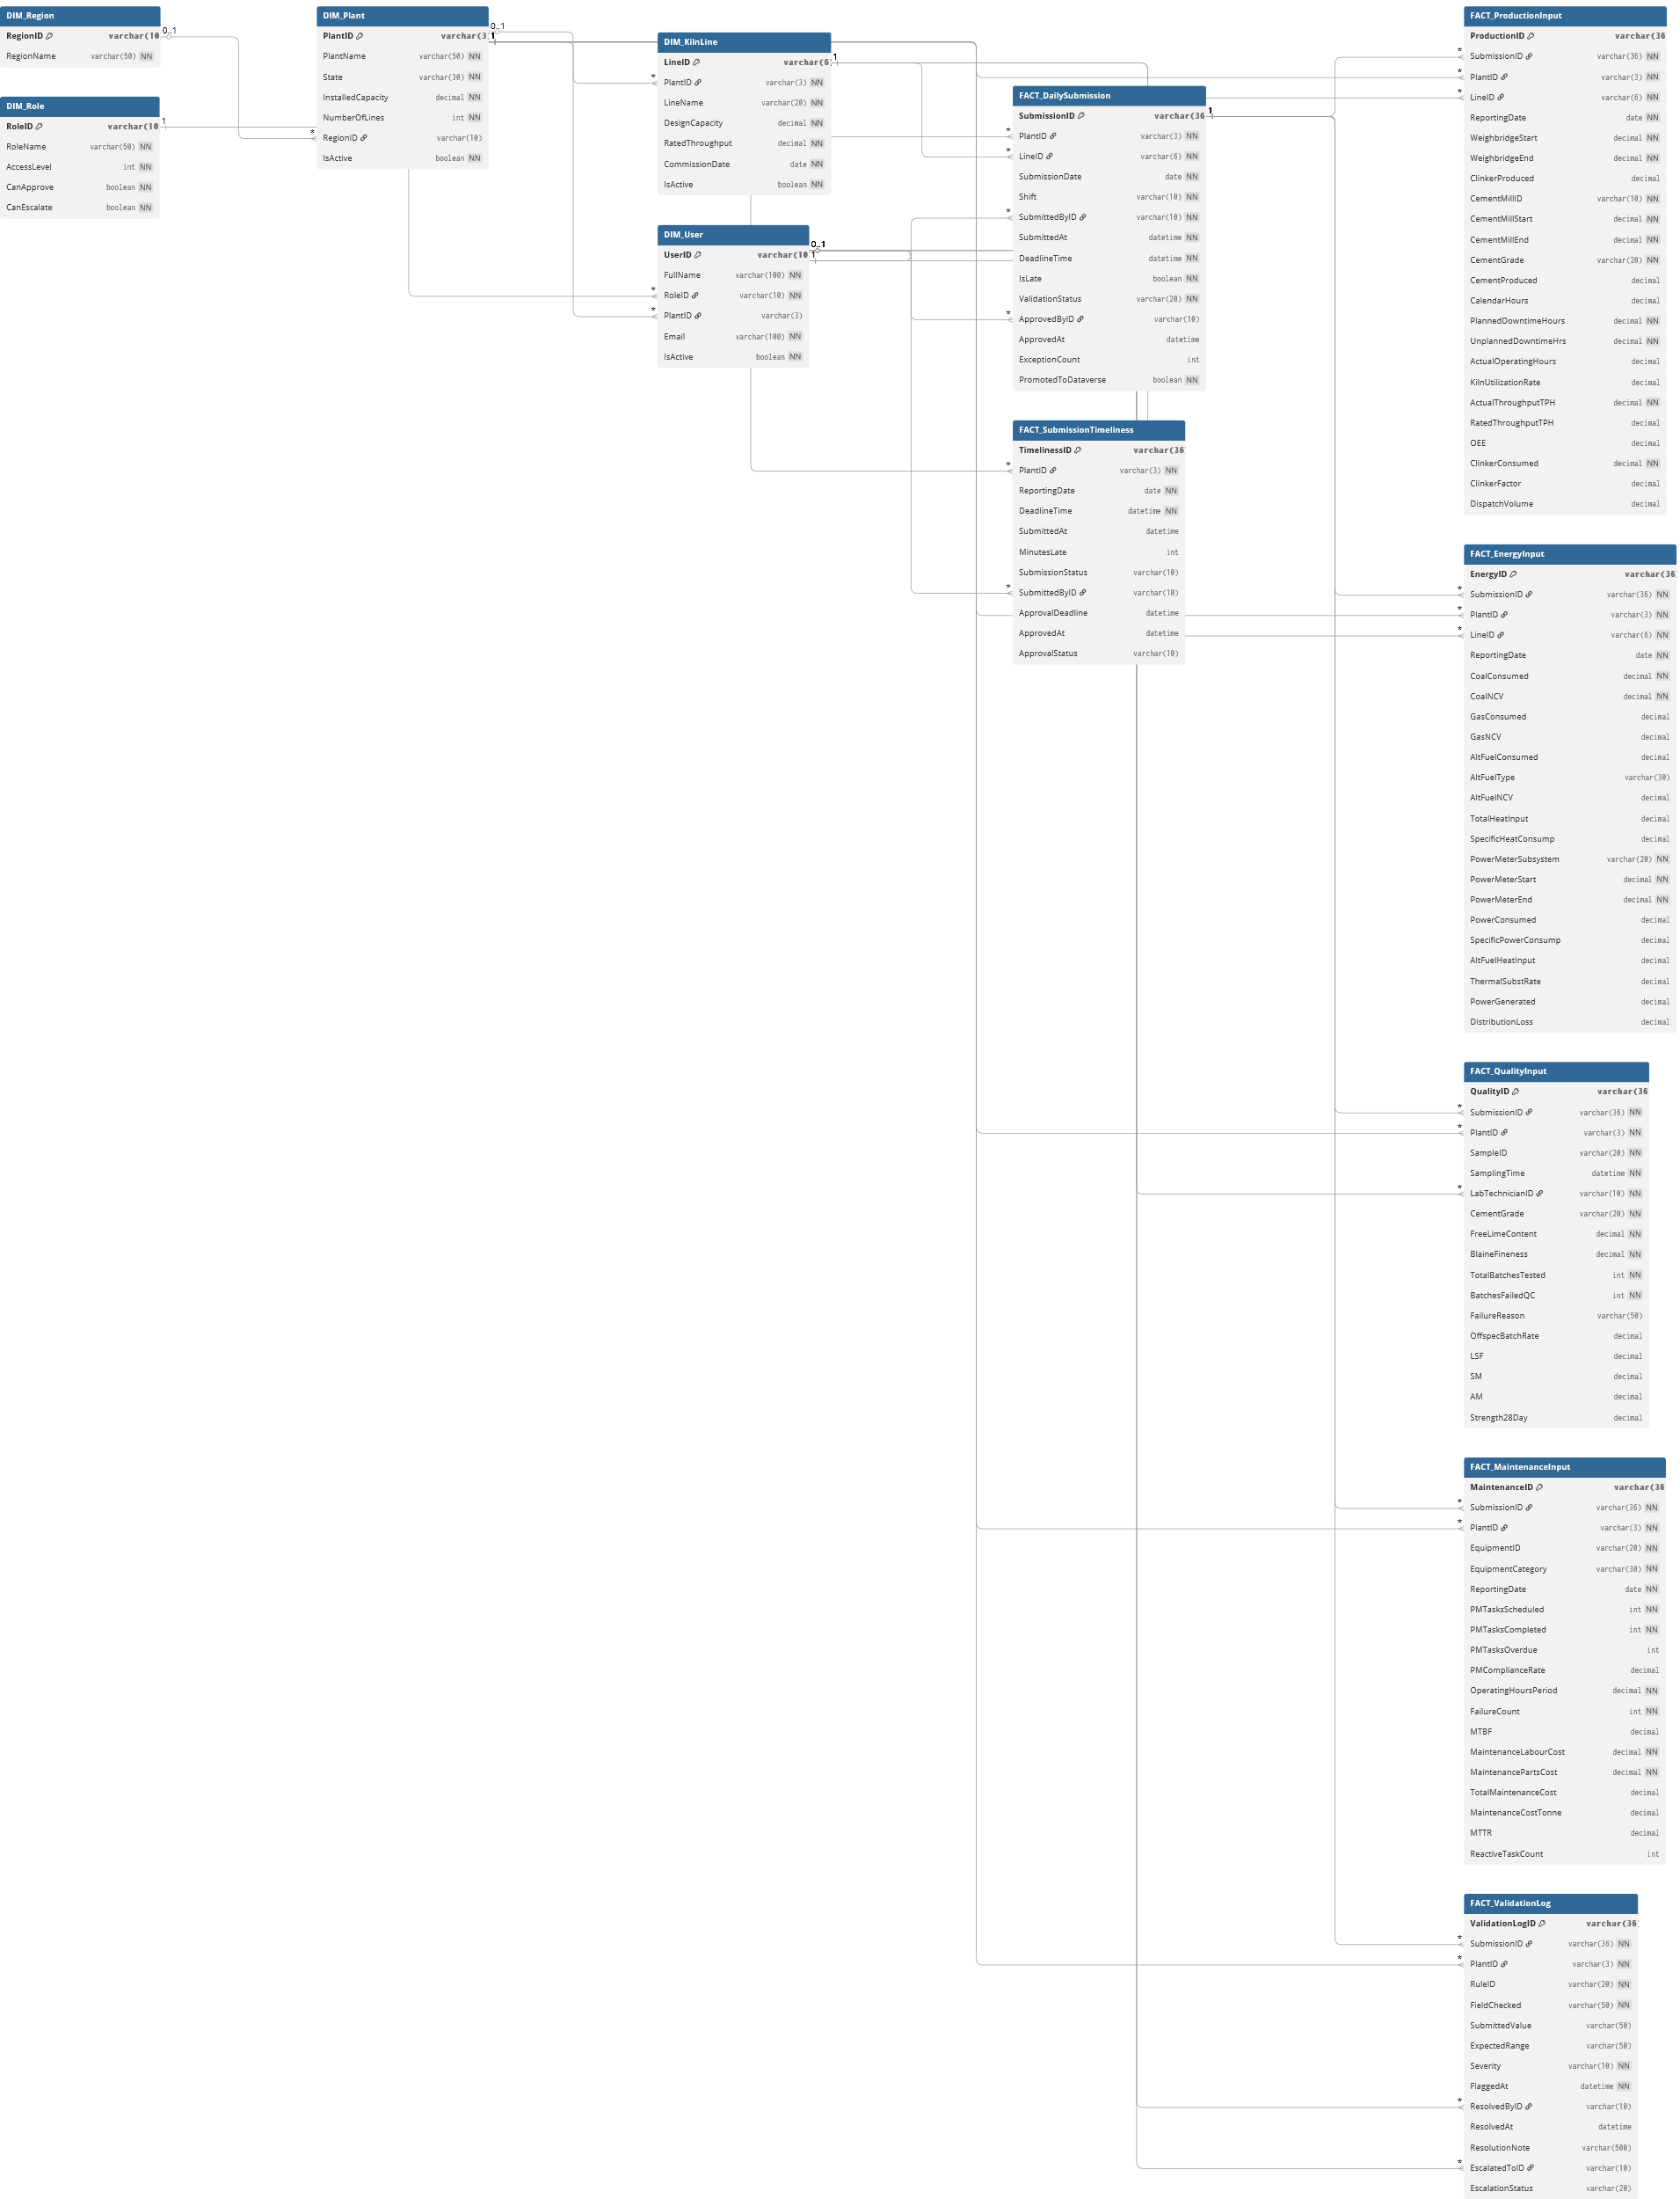

5. SharePoint & Power Apps Configuration Summary
5.1 SharePoint List Structure
Five SharePoint lists form the data entry layer. Each list mirrors a FACT table in the data model (Section 3). Operators enter data via Power Apps, which writes directly to these lists. Power Automate validates the data and promotes clean records to Dataverse for Power BI reporting.
List Name | Maps To | Purpose | Columns
Production Reports (Master) | FACT_DailySubmission | Tracks submission lifecycle, approval, deadlines | 14 total (8 visible, 6 system)
Production Inputs | FACT_ProductionInput | Clinker/cement volumes, OEE, utilization (KPIs 1–6) | 22 (10 visible, 12 calc/system)
Energy Inputs | FACT_EnergyInput | Fuel consumption, power readings (KPIs 7–9) | 17 (8 visible, 9 calc/system)
Quality Inputs | FACT_QualityInput | Lab results, QC batches (KPIs 10–12) | 14 (7 visible, 7 calc/system)
Maintenance Inputs | FACT_MaintenanceInput | Equipment PM, failures, costs (KPIs 13–15) | 16 (8 visible, 8 calc/system)

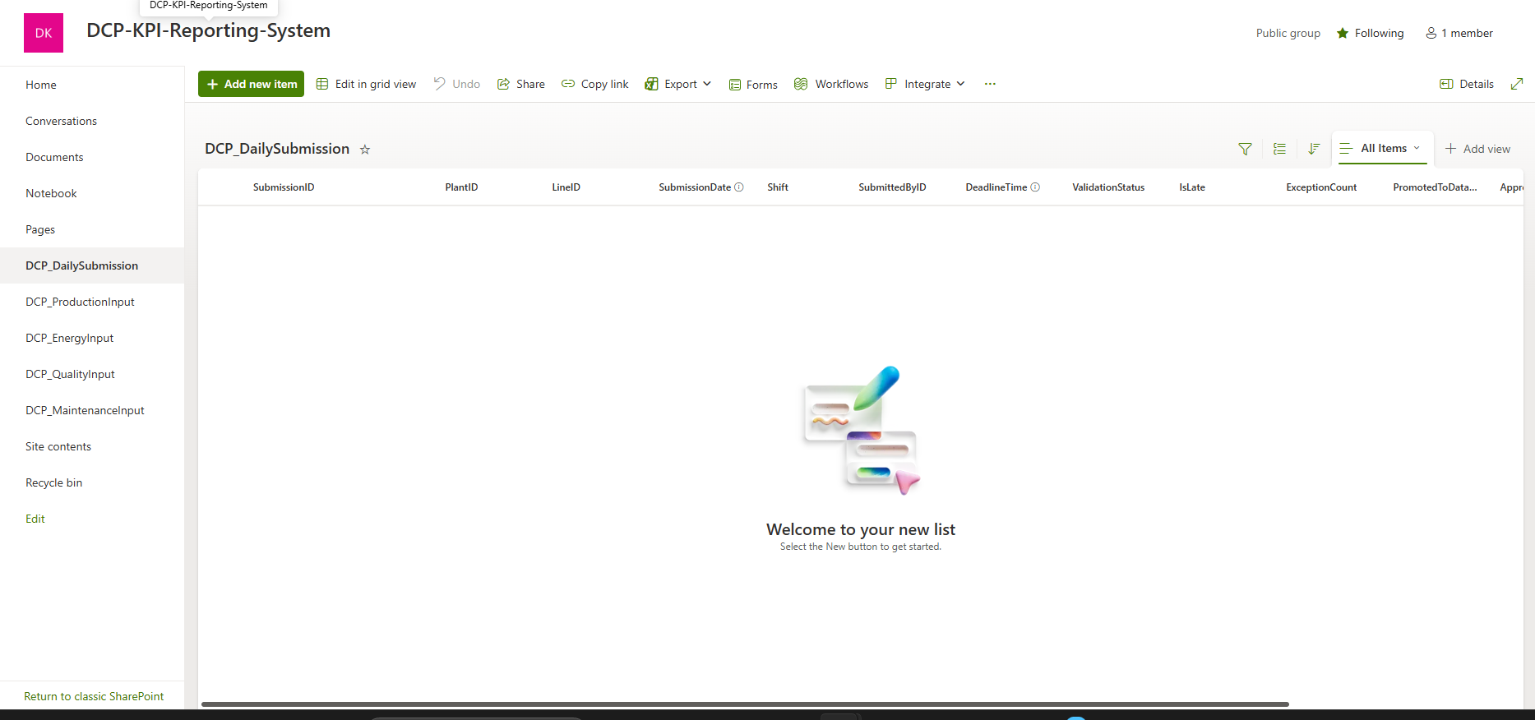Image of FACT_DailySubmission produced in sharepoint
5.1 Power Apps form design
The KPI entry interface was designed as a Power Apps canvas app with tab-based navigation across four input categories — Production, Energy, Quality, and Maintenance. A context strip pinned below the navigation tabs displays the active Plant, Line, Date, Shift, and Operator at all times. Numeric fields are auto-calculated in real time from operator inputs — Clinker Produced, OEE, Kiln Utilization Rate, and Clinker Factor are derived automatically and displayed as read-only fields. On the Quality tab, a dynamic warning banner activates when Free Lime Content exceeds 1.5%, alerting the operator before submission. On submit, the form writes to all five SharePoint lists simultaneously via the Power Apps Patch() function, triggering the Power Automate validation flow.
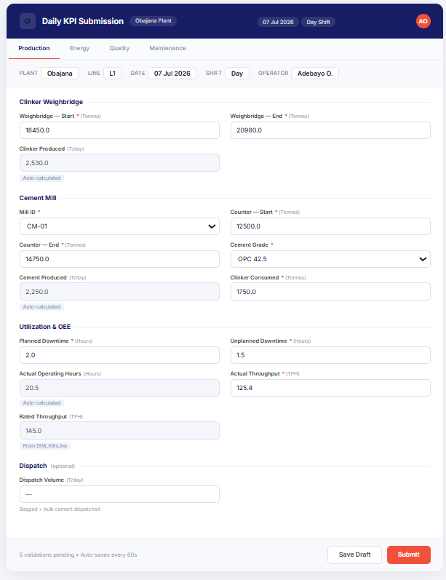
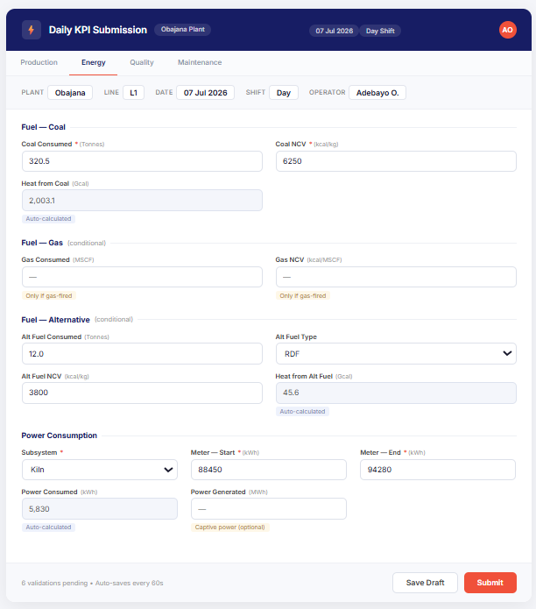
2 of 4 tabs of the Power Apps Form Page

6. Power Automate Flow Diagram
The Power Automate flow manages the complete submission lifecycle: trigger, validation, sign-off, escalation, and Dataverse promotion.
click here for a clearer image

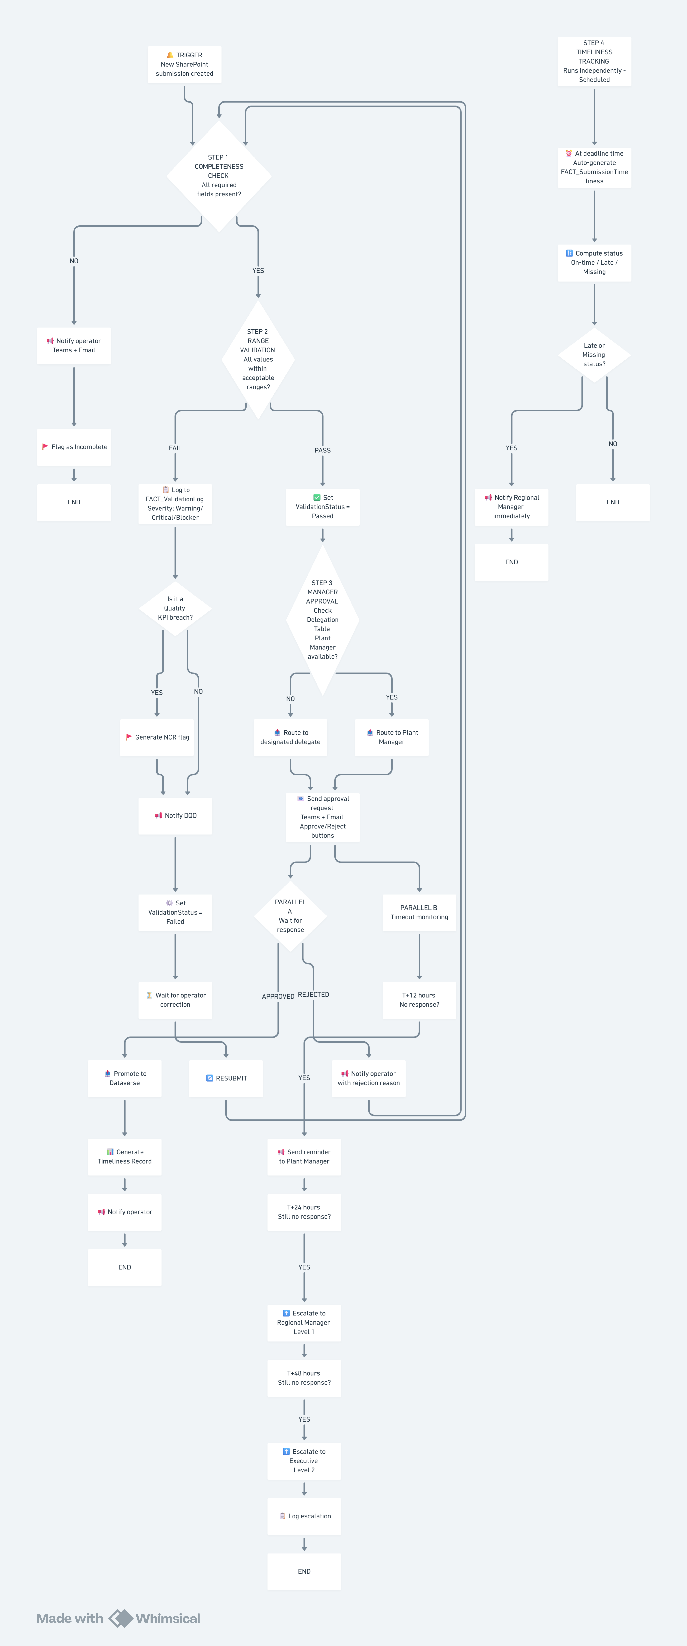

6.1 Flow Steps
Trigger: Flow triggers when a new item is created in any of the 5 SharePoint lists.
Completeness Check: Verifies all required fields (marked REQ in the schema) have values. Missing fields are flagged with severity "Blocker".
Range Validation: Validates numeric values are within acceptable bounds. For example: Free Lime Content must be ≤ 1.5%; Kiln Utilization Rate cannot exceed 100%; no negative values for any measured quantity.
Decision Branch: If all checks pass: route to Plant Manager for approval. If any check fails: log exception to FACT_ValidationLog, notify Data Quality Officer, and raise an NCR (Non-Conformance Report) flag against the submission.
Delegation Check: If the Plant Manager has set a delegate (approval proxy) for the current period, the approval request is routed to the delegate instead.
Approval Process: A Power Automate Approval is sent to the Plant Manager (or delegate). If approved within SLA: mark PromotedToDataverse = True and copy record to Dataverse.
T+12 Reminder: If no action is taken within 12 hours of submission, an automated reminder is sent to the Plant Manager and the DQO is copied.
First Escalation (T+24): If still not approved after 24 hours: the submission is escalated to the Regional Manager, and the Plant Manager is notified of the escalation.
Second Escalation (T+48): If still not approved after 48 hours: the submission is escalated to the Executive level, and all prior recipients are notified of the escalation chain.
Re-submission Loop: If the submission is rejected at any approval level, it is returned to the operator with rejection notes. The operator corrects it and re-submits, re-entering the validation pipeline from the Completeness Check step.
Timeliness Check: At the configured deadline (configurable per plant), the flow computes whether each submission was on-time, late, or missing. Results are written to FACT_SubmissionTimeliness.

7. Validation Rule Library
The validation rule library is organised into four categories: completeness rules, range rules, consistency rules, and timeliness rules. These rules are implemented in Power Automate and triggered on every new submission.

7.1 Completeness Rules
Rule ID | Field | Rule | Severity | KPI Affected
CMP-01 | SubmittedByID | Must not be null | Blocker | All
CMP-02 | SubmissionDate | Must not be null | Blocker | All
CMP-03 | Shift | Must be Day, Night, or Full Day | Blocker | All
CMP-04 | WeighbridgeStart | Must not be null | Blocker | KPI 1
CMP-05 | WeighbridgeEnd | Must not be null | Blocker | KPI 1
CMP-06 | CementMillID | Must not be null | Blocker | KPI 2
CMP-07 | CementMillStart | Must not be null | Blocker | KPI 2
CMP-08 | CementMillEnd | Must not be null | Blocker | KPI 2
CMP-09 | PlannedDowntimeHours | Must not be null | Warning | KPI 3
CMP-10 | UnplannedDowntimeHrs | Must not be null | Warning | KPI 3
CMP-11 | CoalConsumed | Must not be null | Blocker | KPI 6
CMP-12 | CoalNCV | Must not be null | Blocker | KPI 6
CMP-13 | SampleID | Must not be null | Blocker | KPI 9, 10
CMP-14 | FreeLimeContent | Must not be null | Blocker | KPI 9
CMP-15 | BlaineFineness | Must not be null | Blocker | KPI 10
CMP-16 | PMTasksScheduled | Must not be null | Blocker | KPI 12
CMP-17 | PMTasksCompleted | Must not be null | Blocker | KPI 12
CMP-18 | FailureCount | Must not be null | Blocker | KPI 13
CMP-19 | MaintenanceLabourCost | Must not be null | Warning | KPI 14
CMP-20 | MaintenancePartsCost | Must not be null | Warning | KPI 14

7.2 Range Rules
Rule ID | Field | Rule | Severity | KPI Affected
RNG-01 | ClinkerProduced | Must be > 0 and <= plant daily capacity | Critical | KPI 1
RNG-02 | CementProduced | Must be > 0 and <= plant daily capacity | Critical | KPI 2
RNG-03 | KilnUtilizationRate | Must be 0% to 100% | Critical | KPI 3
RNG-04 | OEE | Must be 0% to 100% | Critical | KPI 4
RNG-05 | ClinkerFactor | Must be 0.5 to 0.95 | Critical | KPI 5
RNG-06 | SpecificHeatConsump | Must be 600 to 900 kcal/kg clinker | Critical | KPI 6
RNG-07 | FreeLimeContent | Must be <= 1.5% | Critical | KPI 9
RNG-08 | OffspecBatchRate | Must be <= 2% | Warning | KPI 11
RNG-09 | PMComplianceRate | Must be >= 50% (alert if < 90%) | Warning | KPI 12
RNG-10 | WeighbridgeEnd | Must be > WeighbridgeStart | Blocker | KPI 1
RNG-11 | CementMillEnd | Must be > CementMillStart | Blocker | KPI 2
RNG-12 | PowerMeterEnd | Must be >= PowerMeterStart | Blocker | KPI 7
RNG-13 | PlannedDowntimeHours | Must be >= 0 and <= 24 | Warning | KPI 3
RNG-14 | UnplannedDowntimeHrs | Must be >= 0 and <= 24 | Warning | KPI 3
RNG-15 | TotalHeatInput | Must be > 0 if clinker produced > 0 | Critical | KPI 6

7.3 Consistency Rules
Rule ID | Rule | Severity | Fields Involved | Description
CNS-01 | ActualOpHours + Downtime = CalendarHours | Critical | ActualOperatingHours, PlannedDowntimeHours, UnplannedDowntimeHrs, CalendarHours | Operating hours plus all downtime should equal 24 hours for a daily submission
CNS-02 | If ClinkerProduced > 0 then CoalConsumed > 0 | Warning | ClinkerProduced, CoalConsumed | Cannot produce clinker without fuel input (except during all-electric operation)
CNS-03 | PMTasksCompleted <= PMTasksScheduled | Blocker | PMTasksCompleted, PMTasksScheduled | Cannot complete more tasks than were scheduled
CNS-04 | BatchesFailedQC <= TotalBatchesTested | Blocker | BatchesFailedQC, TotalBatchesTested | Failure count cannot exceed total test count
CNS-05 | ApprovedAt >= SubmittedAt | Blocker | ApprovedAt, SubmittedAt | Approval timestamp cannot precede submission timestamp
CNS-06 | PMComplianceRate = (Completed / Scheduled) * 100 | Warning | PMComplianceRate, PMTasksCompleted, PMTasksScheduled | Value must match the KPI calculation exactly

7.4 Timeliness Rules
Rule ID | Rule | Severity | Description
TML-01 | If SubmittedAt > DeadlineTime then IsLate = True | Critical | Late flag is set automatically by Power Automate
TML-02 | If submission missing by DeadlineTime + 1hr, create "Missing" record | Warning | Generates a FACT_SubmissionTimeliness record with status "Missing"
TML-03 | T+12: Send reminder if not approved within 12 hours of submission; T+24: Escalate to Regional Manager if still not approved | Warning | Two-stage escalation for management-level SLA breach. Reminder at T+12 copies DQO; escalation at T+24 notifies Regional Manager and Plant Manager.
TML-04 | T+48: Escalate to Executive if still not approved after 48 hours | Critical | Final escalation level for critical SLA breaches. All prior recipients are notified of the escalation chain.

8. Power BI Role-Level Security Design
Power BI Row-Level Security (RLS) is implemented using a single report published to the Power BI Service. Five roles are defined in Power BI Desktop, matching the DIM_Role table. The RLS filter is applied through the DIM_User table using the logged-in Microsoft 365 user's email address.

8.1 Roles Defined
Role | Filter Type | Scope
Plant Operator | Row-level (plant-scoped) | Own shift, own line only
Plant Manager | Row-level (plant-scoped) | Full plant, all shifts
Data Quality Officer | None (all data) | All plants, exceptions view
Regional Manager | None (all data) | All 4 plants, operational view
Executive | Column-level (strategic KPIs only) | Strategic and financial KPIs only
DAX filter expression applied to Plant-scoped roles:
DIM_User[Email] = USERPRINCIPALNAME()
&& RELATED(DIM_User[PlantID]) = FACT_DailySubmission[PlantID]

8.2 How RLS Works
- User logs into Power BI Service with their Microsoft 365 credentials.
- Power BI checks the user's email against DIM_User.Email.
- The matching DIM_User record determines RoleID and PlantID.
- The DAX filter associated with that role is applied to all visuals.
- Data outside the role's scope is invisible - not just hidden, but filtered at the query level.

8.3 RLS Implementation Steps in Power BI Desktop
- Create roles in Power BI Desktop (Manage Roles) matching DIM_Role.RoleName (Plant Operator, Plant Manager, Data Quality Officer, Regional Manager, Executive).
- Apply DAX filter: DIM_User[Email] = USERPRINCIPALNAME() for role-based filtering.
- For Plant-scoped roles (Operator, Manager), add: RELATED(DIM_User[PlantID]) = FACT_DailySubmission[PlantID]. This cascades through all relationships.
- Test each role using Power BI Desktop's "View As" function before publishing.
- Publish to Power BI Service and assign members to each role in the Dataset -> Security settings.

8.4 — Power BI Dashboard Design
The Power BI report is structured across four dashboard pages, each filtered by role through Row-Level Security. The Overview page provides a cross-plant KPI scorecard visible to Regional Managers and Executives. The Plant Deep Dive page gives Plant Managers a full view of all 15 operational KPIs for their assigned plant. The Exception Dashboard surfaces all validation flags, severity levels, and resolution status for the Data Quality Officer. The Governance page tracks submission timeliness and approval status across all four plants. All pages are built on the validated Dataverse data store — ensuring every visual reflects only clean, approved submissions.
All dashboard designs files are saved here

Executive Scorecard — strategic-level view of group performance (revenue, OEE, EBITDA, safety, production targets across all plants). Designed for board reviews and monthly leadership meetings.
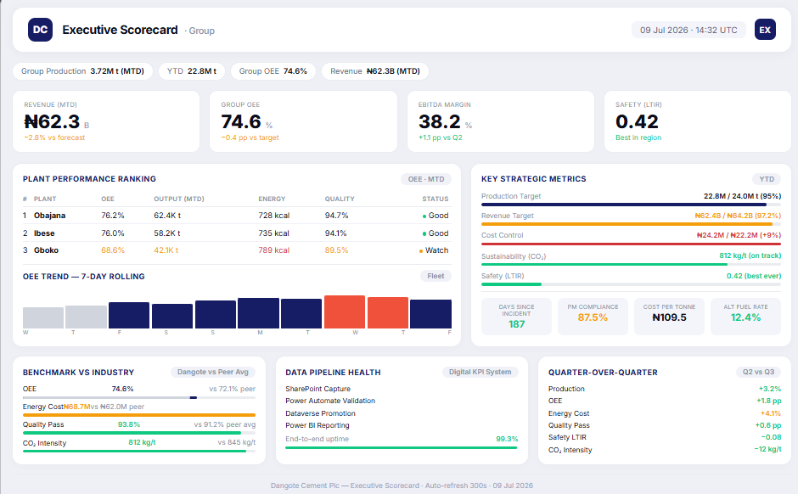

9. Implementation Prerequisites & Assumptions

9.1 Prerequisites
Prerequisite | Details
Microsoft 365 Tenant | Active M365 tenant with SharePoint Online, Power Apps, Power Automate, and Power BI (Pro or Premium per user).
Licensing | Standard M365 E3/E5 for all users (covers SharePoint entry). Power Apps Premium licenses for users accessing Dataverse reports (est. 10-20 users).
Power BI Pro/Premium | Required for RLS functionality and publishing to the service.
SharePoint Lists | 5 lists must be created (as defined in Section 5) before the Power Apps form can be connected.
Dataverse Database | Dataverse must be provisioned in the target environment. Default 3GB database capacity should suffice for the pilot.
Plant Champion | One key operator per plant who can act as the power user for training and ongoing support.
M365 Admin Access | Required for DLP policy configuration, SharePoint list creation, user provisioning, and RLS role assignment in Power BI.

9.2 Key Assumptions
- Dangote Cement operates within standard Microsoft 365 infrastructure (Power Platform is deployable without additional data engineering).
- Plant operators have basic digital literacy sufficient for form-based data entry via Power Apps.
- Daily submission deadline is fixed at 10:00 AM following the reporting day (configurable per plant requirement).
- KPI benchmarks and ranges are derived from industry standards and Dangote publicly available documentation.
- All 4 plants and 12 kiln lines are treated as independent reporting units within the same system.
- The Power Automate flow runs in the default Dataverse environment (no custom environment required for pilot).
- Internet connectivity at plant sites is sufficient for Power Apps form submission during scheduled reporting windows.
- Synthetic data used for the prototype is representative of actual plant operations. Real-world patterns may differ.

9.3 Data Limitations
The following data limitations apply to this submission:
- Synthetic data was generated for the prototype and does not represent actual Dangote Cement plant operations.
- KPI targets and benchmarks are based on publicly available industry standards and may differ from DCP's internal targets.
- Validation rule thresholds will require calibration during the pilot phase using actual plant data.
- The data model assumes each submission covers one shift per kiln line. Plants operating on different shift patterns may require schema adjustments.
- Cost estimates for licensing are based on published Microsoft pricing and may differ based on DCP's enterprise agreement.

10. Business Case — Digital KPI Automation

10.1 Problem & Cost of Inaction
DCP reports 17.7Mt annual cement volume from Nigerian operations with EBITDA margin of 59.6% (2025). Manual KPI reporting across 4 plants creates systematic delays, data errors, and weak governance — directly impacting the ability of management to make timely, data-driven decisions on a ₦3.3 trillion revenue base and ₦1.634 trillion total manufacturing cost base.

10.2 Proposed Solution
A low-code Power Platform system (Power Apps + SharePoint + Power Automate + Dataverse + Power BI) that automates daily KPI data collection, validation, approval, and reporting across all 4 DCP plants. The two-tier storage design (SharePoint for entry, Dataverse for reporting) minimises licensing cost while maintaining data integrity.

10.3 Financial Summary
Item | Value | Notes
Total Initial Investment | ₦8.5M | Power Platform dev, 1st-year licences, training, change mgmt
Annual Licence Cost (run-rate) | ₦3.2M | Power Apps Premium (20 seats) + Power BI Pro (15 seats)
Annual Savings Target | ₦45–70M | Reduced admin time, faster decisions, fewer quality incidents
Payback Period | 2–4 months | From savings in operator/admin time + error reduction
3-Year Net Benefit (conservative) | ₦110–180M | After subtracting 3-year licence and maintenance cost
EBITDA Impact | 0.3–0.5% improvement | Margin uplift from reduced wastage and better OEE tracking

10.4 Key Assumptions
- Each plant employs 5–8 operators submitting daily: ~30 min saved per operator per day = ~₦400/hr loaded cost
- Validation reduces off-spec production by 10% = ~₤15M annual saving per plant (based on industry benchmarks)
- Faster KPI visibility (same-day vs. 3–5 day delay) enables 1–2% OEE improvement within 6 months
- All costs in Nigerian Naira at 2026 estimated pricing; Power Platform licensing costs based on published Microsoft rates
- No additional hardware or infrastructure spend required — runs on existing M365 tenant

10.5 Recommendation
Proceed with an 8-week pilot at Obajana (largest plant, 5 lines, highest reporting complexity) at a cost of ₦2.8M. The pilot validates all assumptions before scaling to the other 3 plants. Investment decision for full rollout at Month 3 based on pilot results.

11. Implementation Roadmap
A three-phase rollout aligned with the executive deck. Each phase has defined actions, owners, and success criteria.

11.1 Immediate (0–30 Days) — Pilot at Obajana
Pilot at Obajana (largest plant, 5 kiln lines, highest reporting complexity).
- Deploy Power Apps form + 5 SharePoint lists configured for Obajana
- Configure Power Automate validation and approval flows
- Set up Power BI dashboard with RLS for all 5 roles
- Train Obajana operators and Plant Manager on the new system
- Run 2-week parallel period — new system alongside existing Excel process
- Compare data quality, timeliness, and user feedback between both systems

11.2 Short-Term (1–3 Months) — Multi-Plant Rollout
Scale to Ibese, Gboko, and Okpella. Retire manual Excel process.
- Roll out to Ibese (Week 5–6), Gboko (Week 7–8), Okpella (Week 9–10)
- Train all operators and plant managers at each site
- Refine validation rules and KPI thresholds based on Obajana pilot data
- Configure DQO and Regional Manager dashboard views
- Full cutover — retire manual Excel-based reporting process across all plants
- Go-live sign-off from each Plant Manager after 1 week of validated parallel run

11.3 Medium-Term (3–6 Months) — Optimization & Scale
Add predictive capabilities, ERP integration, and SCADA links.
- Add predictive exception rules (trend-based alerts for KPI drift)
- Integrate with DCP ERP for automated financial KPI data flow
- SCADA integration for automated kiln feed rate and power consumption capture
- Monthly executive review dashboard with cross-plant benchmarking
- Scale the system template to other DCP business units and regional offices
- Quarterly validation rule review cycle to calibrate thresholds against actual data

11.4 Resources Required
Resource | Role | Effort
Power Platform Developer | Setup, configuration, deployment, integration | 2 weeks initial + 1 week per additional plant
Plant Champion | Key operator per plant — power user & peer trainer | 1 per site (ongoing, ~2 hrs/week)
IT Administrator | M365 tenant config, DLP policies, RLS setup | 1–2 weeks total
Licensing | Existing M365 E3/E5 + Power Apps Premium (20) + Power BI Pro (15) | ₦3.2M/year run-rate

12. Risk & Safety Assessment
The following risk register covers the key operational, technical, and data-governance risks for the proposed digital KPI automation system. Safety is assessed in the context of data safety (integrity, access, and availability) and process safety (quality alerts enabling faster corrective action).

12.1 Risk Register
# | Risk | Description | Likelihood | Impact | Rating | Mitigation | Owner
1 | Data Security Breach | RLS misconfiguration exposes plant data to unauthorised roles | Low | High | Medium | Test all 5 roles pre-launch using Power BI View As function; quarterly RLS audit | IT Admin
2 | Operator Resistance | Operators reject the new system in favour of familiar Excel | Medium | Medium | Medium | Phased rollout with champions; 2-week parallel run to build confidence; “Quick wins” dashboard for each operator | Plant Manager
3 | Data Entry Errors | Operators enter incorrect values that bypass validation rules | Medium | Medium | Medium | Multi-layer validation (completeness + range + consistency); manager sign-off required; DQO exception oversight | DQO
4 | SharePoint Performance | List view threshold (5,000 items) reached over time, degrading performance | Medium | Low | Low | Indexed columns, filtered views, quarterly archiving to Dataverse; clean data only in reporting tier | IT Admin
5 | Power Platform Outage | M365 or Power Platform downtime blocks submission capability | Low | High | Medium | Power Apps offline mode enabled for continuity; 4-hour SLA for restore; manual backup process for critical days | IT Admin
6 | Data Integrity Loss | Records corrupted or lost during SharePoint-to-Dataverse promotion | Low | High | Medium | Full audit trail via FACT_ValidationLog; transactional promotion with rollback; daily Dataverse backup | IT Admin
7 | Inadequate Training | Users unable to use the system correctly, leading to incomplete or poor data | Medium | High | High | Structured training sessions for each role; ‘Train the trainer’ model; reference guide at each plant | Plant Champion
8 | Licensing Cost Overrun | More Dataverse/Power Apps Premium licences needed than budgeted | Medium | Low | Low | Standard M365 covers all operators; only managers need Premium; conservative 20-seat estimate with buffer | Finance
9 | SCADA Integration Delay | ERP or SCADA integration delayed beyond 6-month roadmap | Medium | Medium | Medium | Roadmap treats integration as medium-term; core system works independently; integration is additive, not blocking | Developer

12.2 Safety Assessment
Process Safety: Automated alerts for off-spec quality (Free Lime, Blaine) and equipment failures (OEE drop, MTBF trend) enable faster corrective action, reducing the risk of product quality incidents reaching customers.
The validation system triggers an NCR (Non-Conformance Report) flag when quality parameters breach thresholds, ensuring no off-spec material is dispatched without documented review.
Data Safety:
- RLS ensures role-appropriate data visibility — operators see only their shift and plant
- No manual Excel file handling eliminates the risk of misdirected sensitive plant data
- FACT_ValidationLog provides a complete, immutable audit trail of every submission and exception
- Data at rest is protected by M365 native encryption; data in transit is encrypted via TLS
Operational Safety:
- Low-code (Power Platform) enables plant admins to maintain the system without dedicated IT
- System runs on existing M365 infrastructure — no new hardware, no vendor lock-in
- Offline-capable forms ensure submission continuity during network outages
- Environmental benefit: digital reporting eliminates paper waste from printed Excel reports

